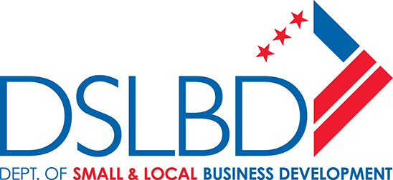
NOTICE OF FUNDING AVAILABILITY

2023 Robust Retail Citywide Grant

Updated 1/19/2023

The District of Columbia (DC) Department of Small and Local Business Development (DSLBD) is excited to announce in this Notice of Funding Availability (NOFA) that DSLBD will be accepting applications for the Fiscal Year (FY) 2023 Robust Retail Citywide Grants program, starting February 1, 2023 and closing April 10, 2023 at 2 p.m. Eastern Time.

A robust retail sector is critical to maintaining the vibrancy of DC neighborhoods, but due to market realities of the past years, retail businesses are still under threat of business decline and closure. The FY 2023 Robust Retail Citywide grants help support existing DC-based retail businesses maintain operations and viability during the current small business crisis.

DSLBD intends to award up to $5,000 each to approximately 100 businesses from the total $500,000 in available funding for FY 2023. The grant funds will reimburse eligible businesses for expenses incurred to maintain business operations and viability. DC retail businesses that have applied and met all eligibility requirements by the final deadline will be entered into a lottery for the final selection of the 100 businesses. Businesses that received a Robust Retail Citywide award in FY 2022 are not eligible to apply.

Final Deadline
The absolute final deadline to apply online is April 10, 2023, at 2:00 p.m. eastern, no exceptions. Applications will only be accepted through DSLBD’s online application system listed in the Request for Applications (RFA) on DSLBD’s website available on or about February 1, 2023.

Who can apply?
Retail Citywide Grants. Home-based, online-only, professional services, and non-profit businesses are not eligible to apply. Businesses with multiple locations are allowed to apply for each respective location, however only one location will be awarded if multiple locations of a business are selected via the lottery. Applicants must be compliant with the eligibility requirements detailed in the RFA.
How can the funds be used?
The grant funds may be used to reimburse for expenses the agency deems reasonable to support maintaining business viability between October 1, 2022 and April 10, 2023. Examples of allowable and disallowed uses are detailed in the RFA.

How will awardees be selected?
Grant recipients will be selected through a lottery process that includes a mechanism for ensuring at least half of the grants are evenly distributed across all 8 DC Wards. All applications deemed eligible and received by or before the deadline will be entered into the lottery system.

The Director will announce the selected grantees and will enter into a grant agreement with each.

How do I apply?
All instructions for applying are included in the RFA and will be available for download or viewing on DSLBD’s website on February 1, 2023 at https://dslbd.dc.gov/service/current-grant-opportunities. Applicants are encouraged to read the full RFA before completing the application.

Questions?
DSLBD will hold virtual information sessions concerning the application process and the grant awards. Details on the date and time of information sessions can be found on DSLBD’s Eventbrite page using the following link: http://bit.ly/DSLBDeventbrite. Applicants are highly encouraged to attend an information session.

All other questions not asked during an in-person information session must be submitted in writing to DCMainStreets@dc.gov. We will begin responding to questions after the grant opens on February 1, 2023.

Reservations
DSLBD reserves the right to issue addenda and/or amendments subsequent to the issuance of this NOFA or the RFA, or to rescind the NOFA or the RFA at any time.

