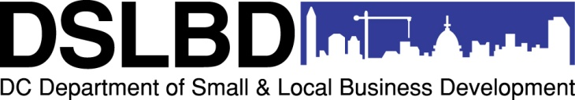
DC Commercial Clean Team Program
EXPRESSION OF INTEREST
Submission Deadline: October 24, 2012, 5:00 pm via email
Interested applicants must complete and submit via email this Expression of Interest form on or before October 24, 2012 at 5:00 pm in order to receive access to the online application form and attend the pre-submission meeting on October 25, 2012. Please type directly into the form, sign, scan and email to camille.nixon@dc.gov. Thank you for your interest in the DSLBD DC Commercial Clean Team Program.
APPLICANT ENTITY
TYPE OF ENTITY (check one): | NONPROFIT BUSINESS, Non-CBE BUSINESS, CBE
NAME:
FEIN #:
DCRA Incorporation File #:
CBE # (if applicable):
STREET ADDRESS (headquarters):
CITY:
STATE:
ZIP CODE:
WEB SITE:
POINT OF CONTACT
NAME:
PHONE:
EMAIL:
AUTHORIZATION TO SUBMIT
By signing below, the business owner or nonprofit board chair is authorizing the point of contact listed above to submit grant applications for the DC Commercial Clean Team Program.
SIGNATURE:
 | Business owner or Nonprofit board chair
PRINT NAME:
DATE:
PHONE:
EMAIL:

