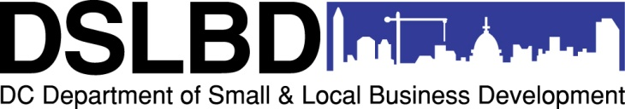
DC Commercial Clean Team Program
EXPRESSION OF INTEREST for Ward 1 Grant Application
Interested applicants must complete, sign, scan and email this form to lincoln.lashley@dc.gov to receive access to the online application form and attend the pre-submission meeting on January 15, 2013. You may type directly into the form. The last day to request application access is January 25, 2013 at 5:00PM. Thank you for your interest in DSLBD’s DC Commercial Clean Team Program.
APPLICANT ENTITY
TYPE OF ENTITY (check one): | NONPROFIT BUSINESS
ORGANIZATION NAME:
FEIN #:
DCRA Incorporation File #:
CBE # (if applicable):
STREET ADDRESS (headquarters):
CITY, STATE, ZIP CODE:
WEB SITE:
ORGANIZATION LEADERSHIP: Business Owner OR Nonprofit Board Chair
PRINT NAME:
TITLE:
DIRECT PHONE:
EMAIL:
By signing below I, the business owner/nonprofit board chair, authorize the following staff to serve as the point of contact, submit the online application and/or attend the January 15, 2013 Pre-Submission Meeting.
SIGNATURE of Business Owner or Board Chair:
POINT OF CONTACT: Staff person who will: 1) ask questions on behalf of the organization; and 2) receive DSLBD communication.
NAME:
TITLE:
PHONE:
EMAIL:
APPLICATION ACCESS (check box for yes): |  |  | Needs access to submit application online
MEETING ATTENDANCE (check box for yes): |  |  | Will attend January 15, 2013 Pre-submission Meeting
OTHER STAFF
NAME:
TITLE:
PHONE:
EMAIL:
APPLICATION ACCESS (check box for yes): |  |  | Needs access to submit application online
MEETING ATTENDANCE (check box for yes): |  |  | Will attend January 15, 2013 Pre-submission Meeting

